Circuit Analysis (Lab 7)

Experiment 7: Analysis of Operational Amplifiers Operations

Name: Muhammad Najeeb Subah Registration No: 2025-CE-91

Date: 01/05/2026 Grade and Signature: …………………

CLO4 | Construct amplifiers with operational amplifiers.
Psychomotor/ Affective | Level1  (1) | Level2 (2-3) | Level3 (4-5) | Level4 (6-7)
Report Marks (3) |  |  | Total marks  (10)

Objective
The objective of this lab is to investigate the input to output relationship for inverting and noninverting amplifiers.

Apparatus Required
Sr. No. | Apparatus | Range | Quantity
1 | Regulated Power Supply | Standard | 1
2 | Signal Generator | Standard | 1
3 | Oscilloscope | Standard | 1
4 | Digital Multimeter | Standard | 1
5 | Breadboard & Wires | Standard | As Required
6 | Resistors | 1k Ω, 2k Ω ,3k Ω | 3

Description
Operational amplifiers can be used in two basic configurations to create amplifier circuits. One is the inverting amplifier where the output is the inverse or 180° out of phase with the input, and the other is the non-inverting amplifier where the output is in the same sense or in phase with the input.
Both operational amplifier circuits are widely used and they find applications in different areas. When an operational amplifier or op-amp is used as a non-inverting amplifier it only requires a few additional components to create a working amplifier circuit.
Pin configuration of IC 741 op amp is shown below
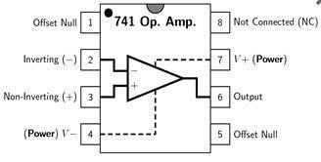
- Pin 1 is offset null.
- Pin 2 is inverting input terminal.
- Pin 3 is a non-inverting input terminal.
- Pin 4 is negative voltage supply (VCC)
- Pin 5 is offset null.
- Pin 6 is the output voltage.
- Pin 7 is positive voltage supply (+VCC)
- Pin 8 has no connection.
Precautions:
- Voltage control knob should be kept at minimum position.
- Current control knob of RPS should be kept at maximum position.
- Carefully utilize the oscilloscope channels and function generator.

Procedure for Inverting Amplifier:
- Wire up the circuit as shown in the figure below on the breadboard.
- Give the input to the inverting terminal of the op-amp and simultaneously display the input and output on the oscilloscope.
- Draw the input & output waveforms at the end of the lab.
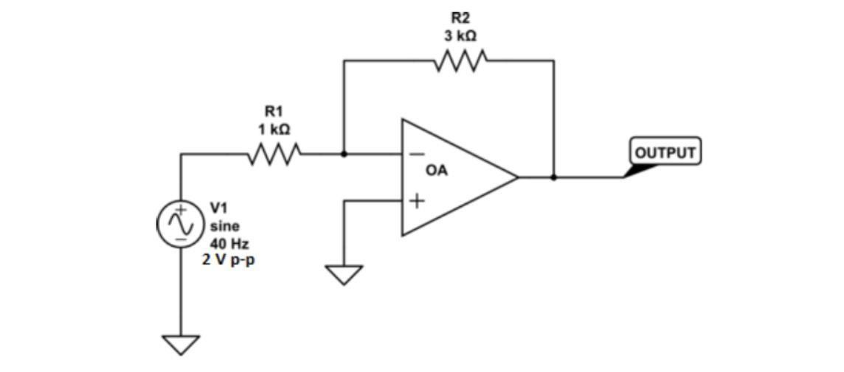
Procedure for Non-Inverting Amplifier:
- Wire up the circuit as shown in the figure below on the breadboard.
- Give the input to the non-inverting terminal of the op-amp and simultaneously display the input and output on the oscilloscope.
- Draw the input & output waveform at the end of the lab.
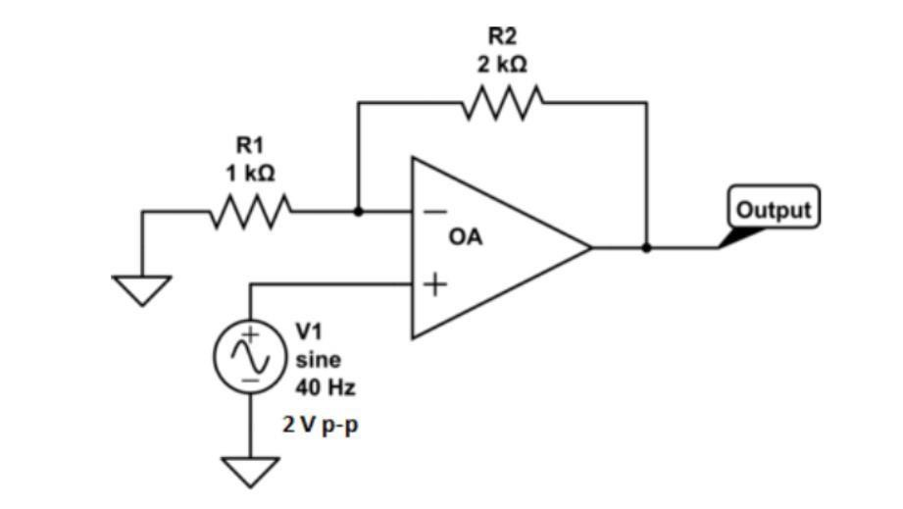
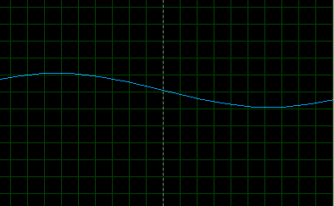
Result:
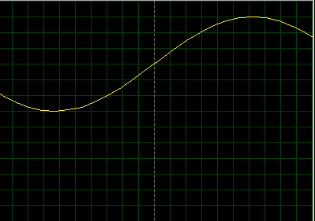


Figure 7: Input Voltage Signal Figure 8: Inverted Output
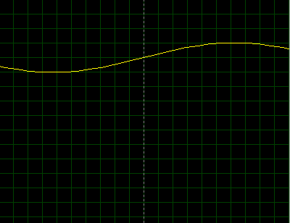

Figure 9: Non-Inverting Output

Post Lab Questions
- Define inverting amplifier.

An inverting amplifier is an op-amp configuration in which the input signal is applied to the inverting (-) terminal, while the non-inverting (+) terminal is grounded.
- The output signal is 180° out of phase with the input (i.e., inverted).
- Define Non-inverting amplifier.

A non-inverting amplifier is an op-amp configuration where the input signal is applied to the non- inverting (+) terminal.
The output signal is in phase with the input (no inversion).

- What are the applications of inverting amplifiers?
- Signal inversion (phase reversal)
- Summing amplifier (adding multiple inputs)
- Integrator circuits
- Differentiator circuits
- Active filters

- What are the applications of non-inverting amplifiers?

- Voltage buffering (used as a voltage follower)
- Signal amplification without phase change
- Impedance matching (high input impedance)
- Sensor signal conditioning

- What is gain of an amplifier?
The gain of an amplifier is the ratio of output signal to input signal.
Av=VoutVinA_v = \frac{V_{out}}{V_{in}}Av​=Vin​Vout​​
It shows how much the amplifier increases the signal strength.

- How do you calculate the gains for inverting and non-inverting amplifiers?
a) Inverting Amplifier Gain:
Av=−RfRinA_v = -\frac{R_f}{R_{in}}Av​=−Rin​Rf​​
- Negative sign → indicates phase inversion
- Depends on feedback resistor RfR_fRf​ and input resistor RinR_{in}Rin​

(b) Non-Inverting Amplifier Gain:
Av=1+RfR1A_v = 1 + \frac{R_f}{R_1}Av​=1+R1​Rf​​
- Always positive
- Output is not inverted

